FELIX WANKEL  Wankel was born in 1903 in Lahr in the Schwarzwald. He was employed in the sales department of a scientific publishing house in Heidelburg from 1921 to 1926. In 1924, he set up a workshop in Heidelburg where he made his first models of a rotary piston engine. Realizing that the principal problem with such designs was gas tightness, he spent considerable time attempting to resolve it. By 1927, the problems were largely solved. During World War II, he worked for the German Luftfahrtministerium (Air Ministry).  In 1951, Wankel and NSU signed a contract establishing a partnership to develop the rotary piston engine.  On 13 April 1954, the first Wankel rotary engine was built by NSU - Vier Takte in einer Maschine, das sind vier Erfindungen in einer einzigen (Four cycles in a single engine are no less than four inventions in one).  In 1956, an NSU prototype motorcycle won all the trials in its category and broke several world records on the Great Salt Lake in the USA, its engine was fed by a Wankel supercharger.  In 1958, NSU started tests on the Wankel engine.  In 1960 the Wankel engine was first discussed in public at the congress of the German Engineers’ Association.  In 1963, NSU launched the Wankel powered Spider at the Frankfurt Motor Show.  In 1964, the COMOBIL company was set up in Geneva - a joint venture between NSU and Citroën - to develop a rotary engined car.  In 1967, the COMOTOR company, another NSU/Citroën joint venture was set up in Luxembourg for the purpose of manufacturing and marketing the Wankel engine. At the Frankfurt Motor Show, NSU unveiled the Ro80, which went on sale in 1968.  In 1969, COMOTOR purchased 850 000m³ of land in the Saar to build a factory where the Wankel engine would be produced.  In 1970, Citroën produced the M35 prototype.  Engine  Single rotor Wankel  993 cm³ swept volume  6 CV fiscal rating  9:1 compression ratio  49 bhp @ 5 500 rpm  7 mkg (50,6 lb ft) torque @ 2 745 rpm  Water cooled  Suspension  Hydropneumatic self leveling on all four wheels  Brakes  Front discs, rear drums  Body  Modified Ami 8 two door coupé  Wheelbase 2,4m,  Front track 1,26m  Rear track 1,22m  Length 4,05m  Width 1,554m  Height 1,35m  Weight 815kg  Performance  Max speed 144 kph  0 - 100 kph 19 seconds  9,68 l/100km  Between 1971 and 1972, 267 M35s were provided to selected clients under the supervision of Citroën who maintained the vehicles. 30 000 000 km were covered by these mobile test beds and the information gathered allowed the design to be improved - particularly with regard to gas sealing, the trochoid’s wall lining and cooling.  In parallel, a new twin rotor engine, based on the M35 unit, was developed and in 1972, the first such engines were delivered from the COMOTOR plant at Altforweiler in the Saar.  How the COMOTOR engine works  The engine operates on the four stroke principle, viz:  Stage 1. The air/petrol mixture moves in through the inlet port.  Stage 2. The rotor then shuts off this port and compresses the mixture.  Stage 3 The fuel mixture is ignited by the spark plugs at the point of highest compression. The burning mixture expands causing the rotor to rotate thereby providing the motive power.  Stage 4 The rotor clears the exhaust port allowing evacuation of the exhaust gases.  The rotary piston, also known as the rotor is shaped like an equilateral triangle with curved side and moves within a stator or trochoid in a motion known as epitrochoid, which allows for volume changes within the “combustion chamber.” The gearing between the rotor and output shaft is such that for a rotor speed of 1 000 rpm, the output shaft revolves at 3 000 rpm.  The COMOTOR 624 engine was fitted in the short lived GZ Birotor  Number of rotors 2  Swept volume 1 990 cm³  11 CV fiscal rating  9:1 compression ratio  107 bhp @ 6 500rpm  14 mkg (101,3 lb.ft) @ 3 000 rpm
  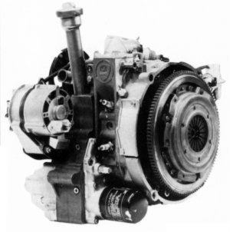
  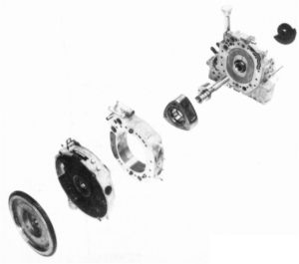
  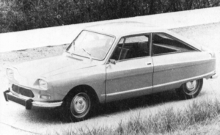
  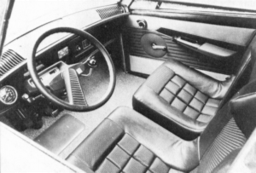
  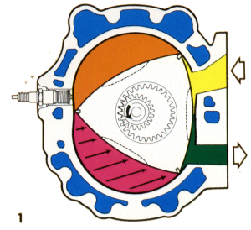
  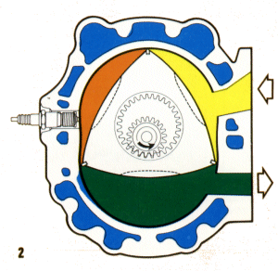
  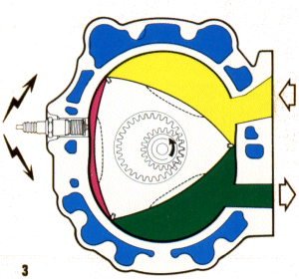
  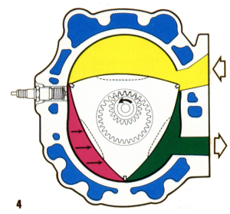
  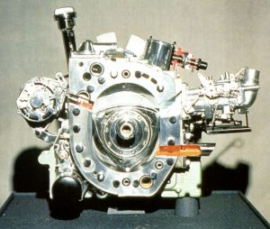
Problems with gas tightness, exhaust emissions and high fuel consumption, which also coincided with both the Middle East oil crisis and the Peugeot take over led to the abandonment of the Wankel project by Citroën. The Ro80 soldiered on for a few more years and nowadays, only Mazda builds Wankel powered cars, having solved the rotor tip wear problems. Mercedes Benz, Rolls Royce and GM have all investigated the Wankel engine but the reality sadly did not meet expectations.
In theory, a rotary engine should be turbine smooth and much more efficient than a conventional engine. Furthermore, the number of moving components is greatly reduced in comparison to a conventional engine while the total number of components is approximately ten per cent of those in a normal engine. This results in a considerable reduction in weight, an improvement in efficiency and a reduction in manufacturing costs.
Certainly power outputs were considerably greater than an equivalent capacity reciprocating engine - the swept volume figures quoted here are actually double those of the actual cubic capacity; thus the M35 engine was really 497 cm³ and the Birotor was 995 cm3. The engines were indeed much smoother than conventional engines and were willing to rev quite freely - indeed it was felt necessary to fit both a warning buzzer and an ignition cut out to prevent over revving. The prime shortcomings were an almost linear torque “curve” (which meant that both the Ro80 and Birotor had to be fitted with semi automatic gearboxes equipped with a torque converter to allow for torque multiplication at low engine speeds) and excessive rotor tip wear which led to high oil and fuel consumption, loss of power and high emissions. With modern technology and electronic controls, the engine can be made to work reliably and is extremely attractive but high fuel consumption remains a bugbear. In the seventies, the technology was simply not up to the task. Had the engine been made to work efficiently, it is likely that it would have provided the power source for the CX; in the event, the CX was fitted with the engine from the DS.
NSU was absorbed within the Volkswagen/Audi group and Citroën within the Peugeot group.
How the Wankel rotary engine works

